RS-1 Atlatl lower stage
Technical specifications and assembly instructions
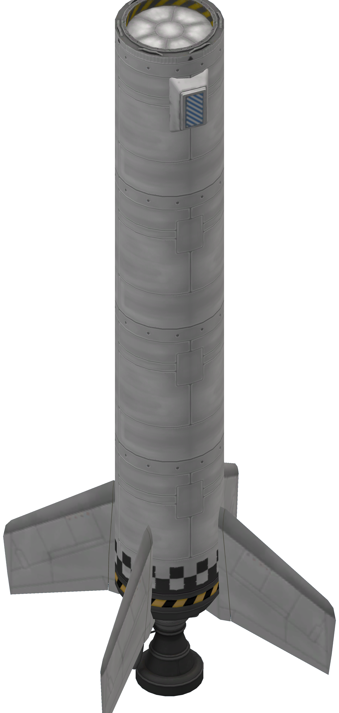
Table of Contents
Description 3
Basic construction 3
Guidance system 3
Recovery system 3
Assembly instructions 4
Technology 4
Fin subassembly 4
Part list 4
Assembly procedure 4
Parameters 5
Parachute subassembly 7
Part list 7
Assembly procedure 7
Parameters 7
Final assembly 9
Part list 9
Assembly procedure 9
Stage configuration 9
Staging 9
Parameters 10
Post flight maintenance 11
Pre flight checks 11

Description
The RS-1 Atlatl stage is a low tech, Reliant-based dumb launch stage. Optimized for low atmosphere flight. The stage comes in different variants differing in propellant capacity and is fully recoverable using built-in parachutes.
This stage has no onboard computer and control is delegated to either the upper stage computer or the payload. Stage recovery is completely passive.

Basic construction
The stage is constructed using two subassemblies. The lower part of the stage uses a subassembly with the engine, a fuel tank and 4 fins. The fins are set at 45 degrees from yaw and pitch planes. The uppermost part of the stage is created using a parachute subassembly. It contains a fuel tank, a pair or parachutes and a TD-12 decoupler. Between the two subassemblies a number of T400 tanks can be installed. This number can go from 0 to 2 and determines which variant is constructed.
Number of additional tanks | Variant | Notes
0 | RS-1A
1 | RS-1B
2 | RS-1C | Stage requires boosters to perform properly

Guidance system
Guidance is provided by the four fins in the engine subassembly. Engine gimballing is not used as the Reliant engine is fixed to its frame.

Recovery system
Stage recovery is provided by the parachutes. No control after stage separation is possible. Separation should take place when the propellant tanks are empty. Damage may occur if landing is attempted with propellant in the tanks.

Assembly instructions
If possible, use prefabricated subassemblies. While less precision is needed compared to earlier versions, prefab subassemblies ensure repeatable results. Also store a reference stage when complete.

Full bill of materials
4x AV-8R Winglet
1x LV-T30 "Reliant" Liquid Fuel Engine
2x FL-T400 Fuel Tank
2x Mk2-R Radial-Mount Parachute
1x TD-12 Decoupler
Extra FL-T400 Fuel Tank required for B and C variants.

Technology
This stage requires a level 4 technology level.
- Advanced Rocketry
  - Reliant engine
  - T400 tanks
- Flight Control
  - Fins
- Survivability
  - Parachutes
- Engineering 101
  - Decoupler

Fin subassembly

Part list
4x AV-8R Winglet
1x LV-T30 "Reliant" Liquid Fuel Engine
1x FL-T400 Fuel Tank

Assembly procedure
- Select LV-T30 engine as root part. Gas generator exhaust should face western orientation.
- Install FL-T400 axially above engine. Use dark "checkerboard" pattern.
- Install AV-8R winglets radially over tank using 4x symmetry and snap.
  - Orientation should be NE/SE/SW/NW.
  - Align fin height by matching second to lowest panel junction (line separating middle of fin) to exactly the centre of lower tank checkerboard line.
  - When aligned, lowest junction should point to end of engine shroud.

Parameters
Part count: 6
Subassembly cost: 4160 (full), 3976 (dry)
Subassembly mass: 3900 Kg (full), 1900 Kg (dry)
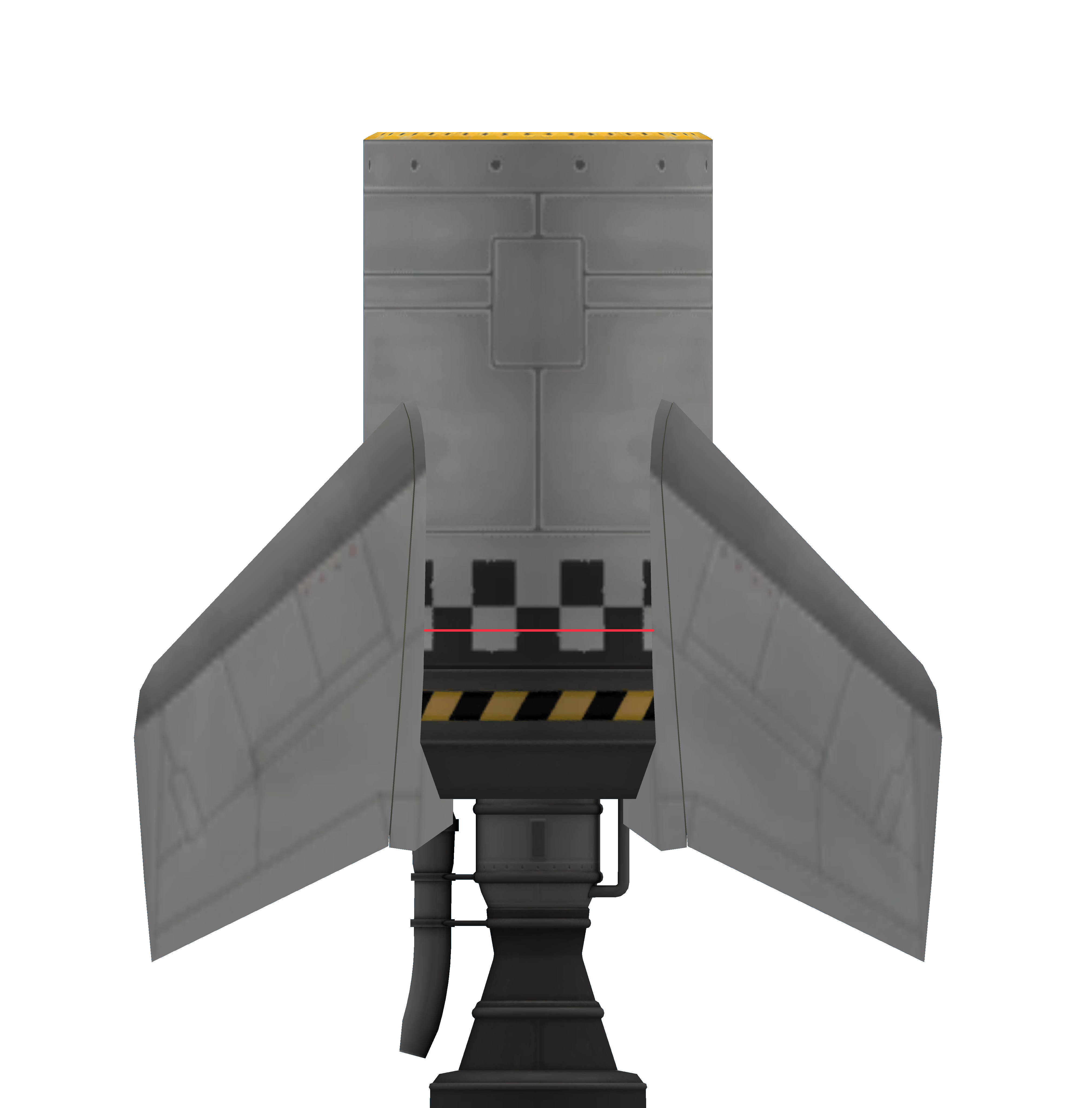Figure 1: RS-1 fin subassembly. Red line highlights fin alignment to checkerboard pattern.

Parachute subassembly

Part list
1x FL-T400 Fuel Tank
2x Mk2-R Radial-Mount Parachute

Assembly procedure
- Select fuel tank as root.
  - Use dark "checkerboard" or white pattern.
- Install parachutes radially on 2x symmetry with snap.
  - Parachute orientation should be N/S.
  - Parachute tips should touch base of lower junction of rivet line panel on top of stage.

Parameters
Part count: 3
Subassembly cost: 1300 (full), 1116 (dry)
Subassembly mass: 2450 Kg (full), 450 Kg (dry)
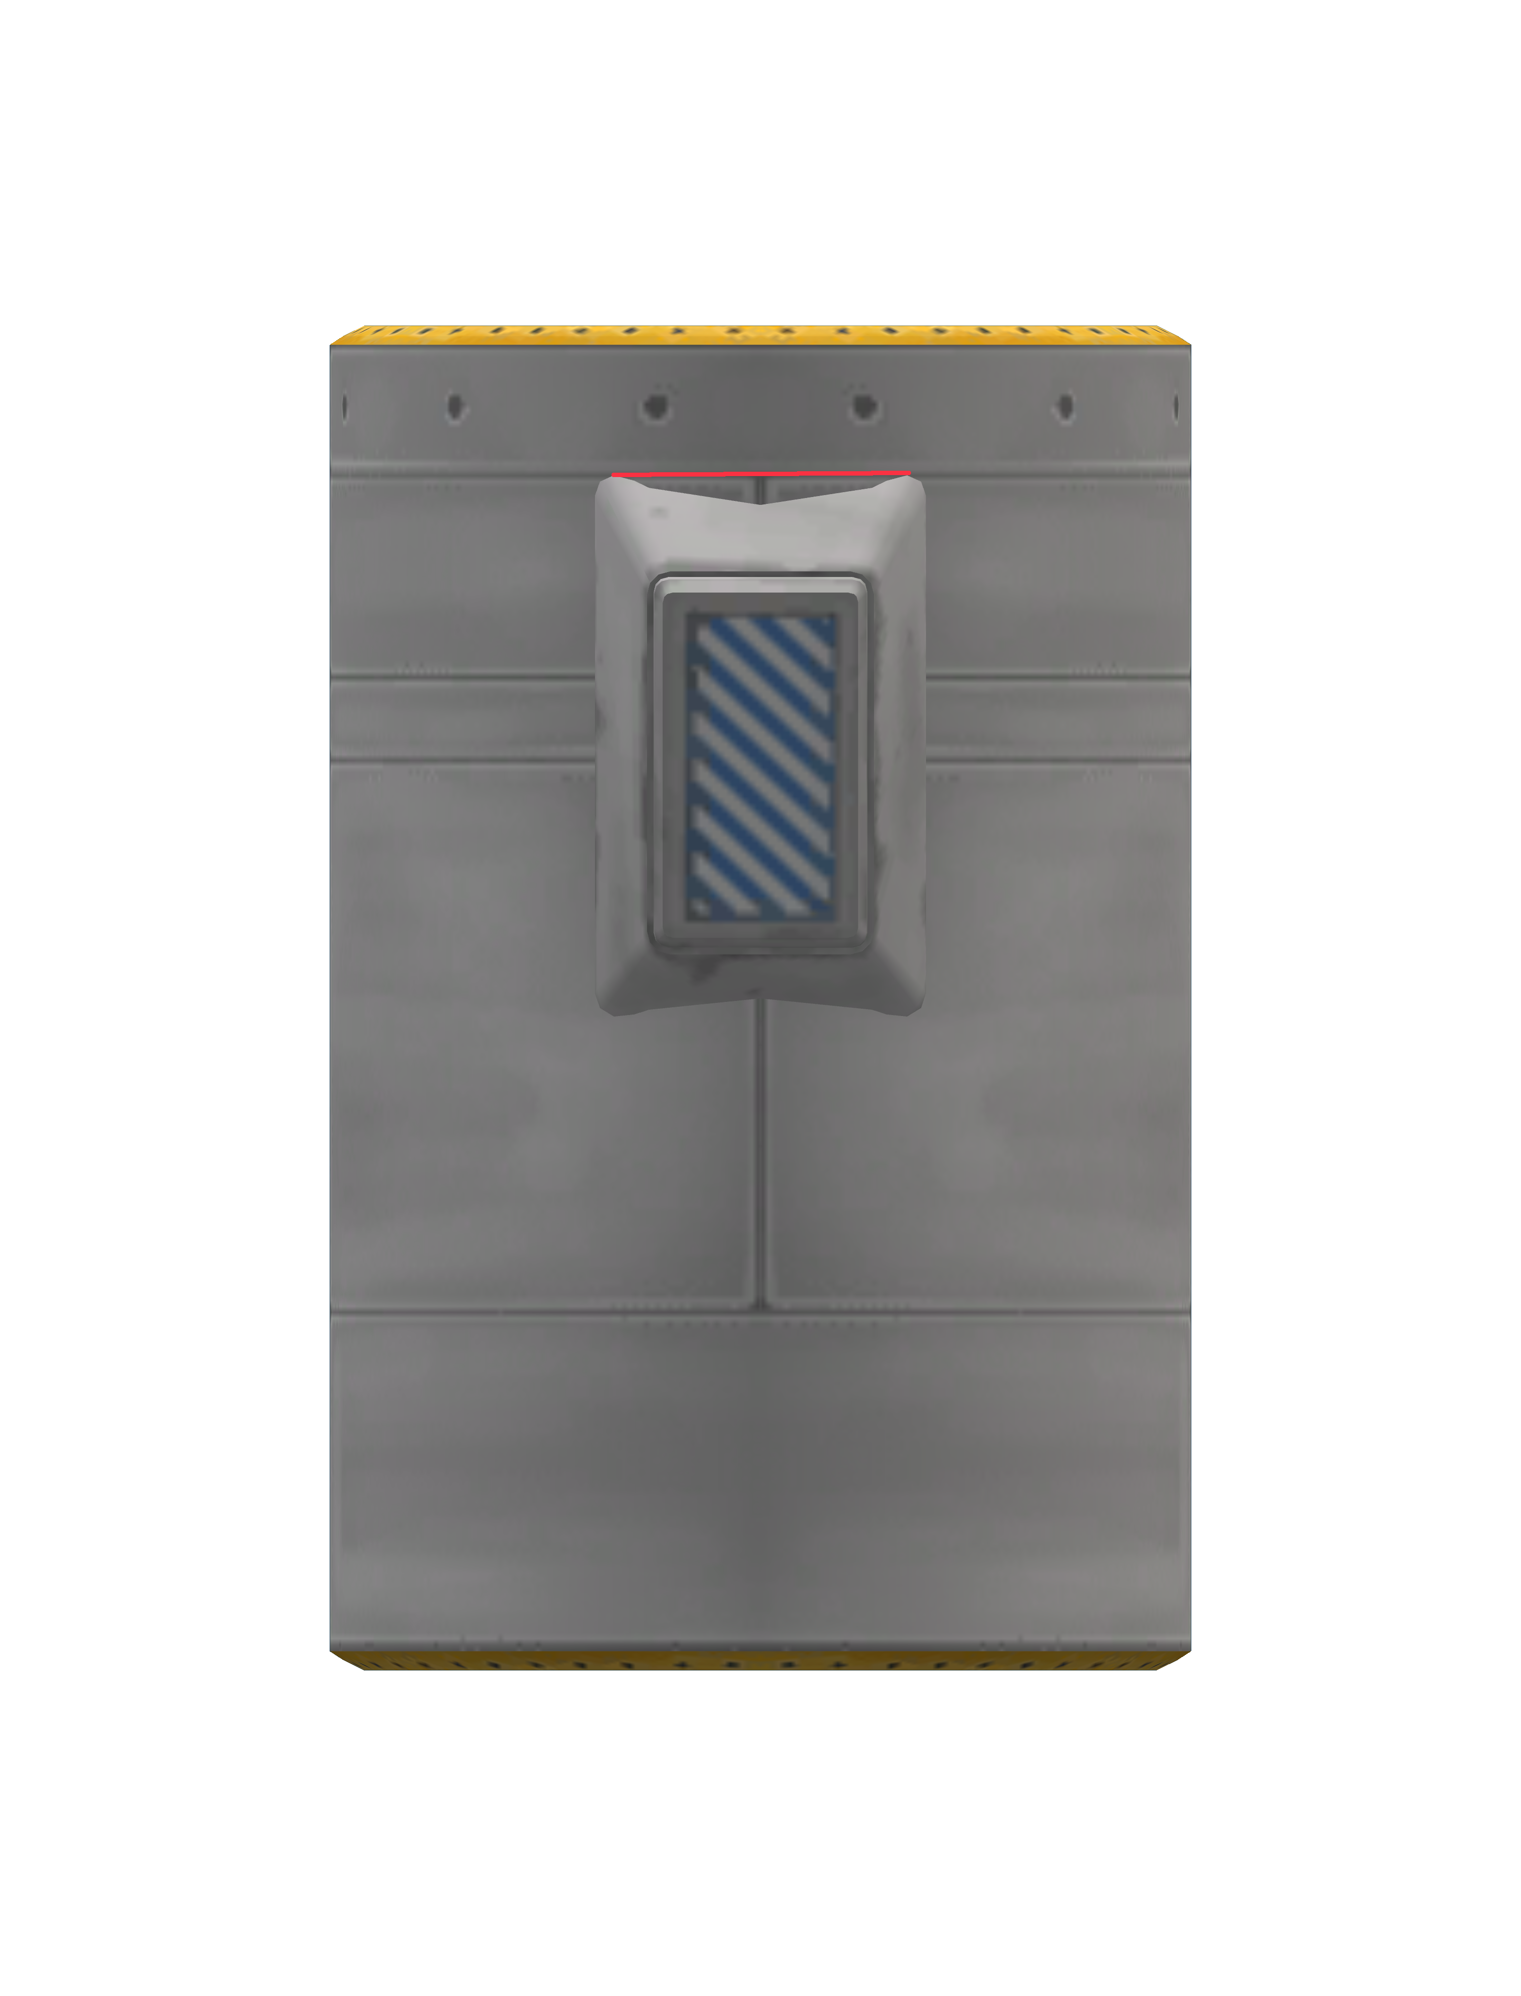Figure 2: RS-1 parachute subassembly. Red line goes from tip of parachute and shows overlap with "rivet panel" junction.

Final assembly

Part list
1x RS-1 fin assembly
1x RS-1 parachute assembly
1x FL-T400 Fuel Tank (for B variant) or
2x FL-T400 Fuel Tank (for C variant)
1x TD-12 Decoupler

Assembly procedure
- Start with fin assembly
- Assemble extra tanks axially over fin assembly
- Connect parachute assembly axially over tanks
- Connect decoupler axially over upper parachute assembly tank

Stage configuration
Part | Variable | Value | Default | Notes
Fins | Pitch | Active | Yes
Fins | Yaw | Active | Yes
Fins | Roll | Active | Yes
Fins | Deploy | Retracted | Yes
Fins | Deploy direction | Normal | Yes
Fins | Deploy angle | 0 | No
Fins | Authority limiter | 4 | No
Engine | Throttle | Main throttle | Yes
Engine | Thrust limiter | 100 | Yes
LFOX tank 1 | Flow priority | 0 | Yes | Uppermost tank
LFOX tank 2 | Flow priority | +1 | No
LFOX tank 3 | Flow priority | +2 | No | If present
LFOX tank 4 | Flow priority | +3 | No | If present
Decoupler | Force percent | 100 | Yes
Decoupler | Enable crossfeed | False | Yes
Decoupler | Enable staging | True | Yes
Parachutes | Deploy mode | When safe | Yes
Parachutes | Min pressure | 0.45 | No
Parachutes | Altitude | 500 | No
Parachutes | Spread angle | 10 | No

Staging
Stage | Parts | Notes
0 | Parachutes, decoupler
1 | Engine

Parameters
Parameter | RS-1A | RS-1B | RS-1C
Mass (dry, kg) | 2390 | 2640 | 2890
Mass (wet, kg) | 6390 | 8640 | 10890
Cost (wet) | 5660 | 6160 | 6660
Cost (dry) | 5293 | 5609 | 5926
Part count | 10 | 11 | 12
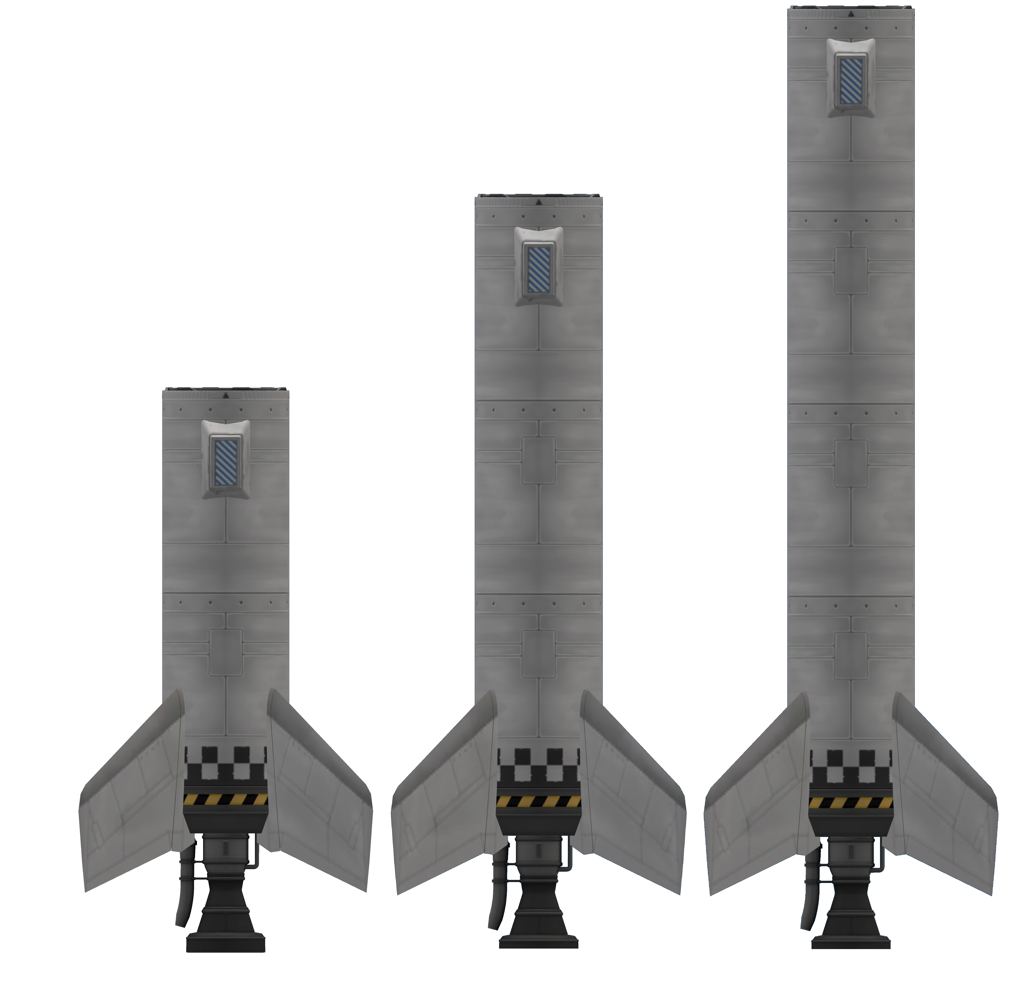Figure 3: RS-1 family. RS-1A to the left, RS-1B at the center and RS-1C to the right.

Post flight maintenance
- RS-1 Decoupler
  - Enable staging
- Tanks
  - Fill

Pre flight checks
- Verify staging
- Verify parachute settings

